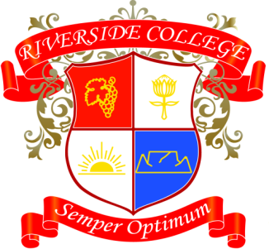
Riverside College
2018
Grade 10
Assessments: Term 3

Date | Subject | Assessment
31/07 | Afrikaans | Mondeling
01/08 | LO | PE Assessment 1
07/08 | Physical Science | Experiment 3
07/08 | Math/lit | Investigation
14/08 – 16/08 | LO | Job Shadowing
17/08 | History | Essay
21/08 | Math | Controlled Test
21/08 | English | Oral
27/08 | Accounting | Task
27/08 | LO | Project
28/08 | CAT | AVG Test Prac
28/08 | Business Studies | Task
29/08 | LO | PE Assessment 2
31/08 | Design | Process
07/09 | Life Science | Practical
17/09 | Design | Product
17/09 | Life Science | Project

