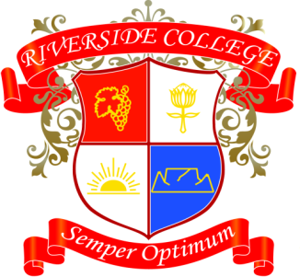
Riverside College
2018
Grade 11
Assessments: Term 3

Date | Subject | Assessment
30/07 | Afrikaans | Mondeling
23/07 – 03/08 | VA | Steps 1 - 4
01/08 | LO | PE Assessment 1
07/08 | Math/lit | Investigation
09/08 | Physical Science | Experiment 3
13/08 | VA | Step 5
14/08 – 17/08 | LO | Job Shadowing
21/08 | English | Oral
21/08 | Math | Controlled Test
22/08 | History | Essay
24/08 | VA | Step 6 – Final Practical
27/08 | Business Studies | Task
27/08 | LO | Project
28/08 | CAT | AVG Test Prac
29/08 | LO | PE Assessment 2
30/08 | Geography | Research Task
31/08 | Design | Process
03/09 | Life Science | Practical
17/09 | Life Science | Project
17/09 | Design | Product

