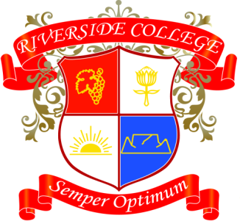
Riverside College
2018
Grade 12
Assessments: Term 3

Date | Subject | Assessment
30/07 | VA | Internal Prac Part 1+2
31/07 | Physical Science | Experiment 3
31/07 | VA | 2 x Collage
14/08 | VA | Internal Prac - Final
21/08 | CAT | AVG Test Prac
21/08 | English | Oral
22/08 | Math | Controlled Test
27/08 | Business Studies | Task
27/08 | Accounting | Task
28/08 | Afrikaans | Mondeling
30/08 | Geography | Research Task
07/09 | Life Science | Practical

