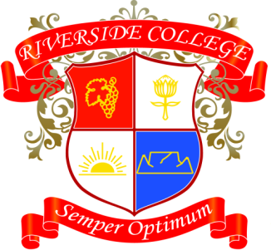
Riverside College
2018
Grade 7
Assessments: Term 3

Date | Subject | Assessment
31/07 | English | Oral
02/08 | Afrikaans | Beskrywende Opstel
02/08 | LO | PE Assessment 1
07/08 | Afrikaans | Agenda en Minute
07/08 | History | Source based writing
07/08 | English | Writing task
10/08 | Geography | Data Handling
14/08 | English | Writing task
16/08 | Afrikaans | Lees
21/08 | CA | Art Prac Final
24/08 | Technology | Mini-Pat
29/08 | Math | Assignment
30/08 | LO | PE Assessment 2
31/08 | EMS | Entrepreneurs Day
31/08 | NS | Practical
03/09 | CA | Drama Prac
17/09 | NS | Project
20/09 | LO | Project

