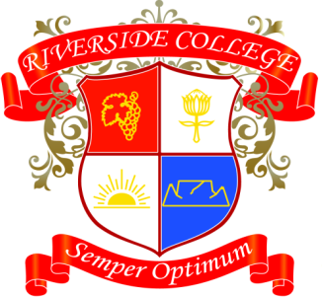
Riverside College
2018
Grade 8
Assessments: Term 3

Date | Subject | Assessment
31/07 | English | Oral
02/08 | LO | PE Assessment 1
03/08 | Afrikaans | InformeleBrief
07/08 | English | Writing task
08/08 | Geography | Project
08/08 | Math | Assignment
13/08 | Afrikaans | Beskrywende Opstel
14/08 | English | Writing task
21/08 | CA | Art Prac - Final
23/08 | Math | Project
28/08 | Afrikaans | Mondeling
30/08 | LO | PE Assessment 2
31/08 | EMS | Entrepreneurs Day
03/09 | CA | Drama Prac
06/09 | NS | Practical
07/09 | History | Source based paragraph and essay
15/09 | Technology | Pat
18/09 | NS | Project
20/09 | LO | Project

